
Company Logo
Company Name
Project Name
(Background image that best represents the proposal)

Detailed Project Report (DPR)
for
____ (Project Name) ____

Submitted by

…………………………… (Applicant with full correspondence Address)

Detailed Project Report (DPR) will have to be signed by the applicant (s) / authorized person (in case of legal entity) on each page with date -along with Sector and Project Finance Expert wherever applicable.

Table of Contents
Executive Summary 5
1. Investor and Company Profile 8
1.1 About the Company 8
1.1.1 Primary Sectoral Competencies and Business Experience of Company 8
1.1.2 Annual Turnover (last 5 years) 8
1.2 Promoters of the Company 9
1.2.1 Brief Profile of the Promoters 9
1.3 Details of Existing Business Concerns 10
1.3.1 Brief Profile of the Companies 10
2. Details of the proposed project investment 11
2.1 Brief on the proposed project 11
2.2 Project Description 11
2.3 Market analysis/ justification for proposed project 11
2.4 Proposed products to be Produced at the facility 11
2.5 Justification for the extent of land required for the proposed project. 11
2.6 Raw material: 12
2.6.1 Availability and Source of Raw Materials 12
2.6.2 Annual Requirement and Cost of Raw Materials and Utilities 12
2.7 Manufacturing/ Service Process 12
2.8 Proposed Employment to be generated (Direct & Indirect) in various phases 13
2.9 Project Implementation Timeline 13
2.10 Energy Conservation 13
2.11 Effluent Treatment 14
3. Financial analysis to justify the feasibility of the proposed project. 15
3.1 Project Investment 15
3.2 Means of Finance 15
3.3 Assumptions for Financial Model 15
3.4 Manpower Costs 15
3.5 Input/Operational Costs 16
3.6 Revenue from Operations 16
3.7 Depreciation 17
3.8 Projected Profit and Loss Account 17
3.9 Term Loan Repayment Schedule 18
3.10 Debt Service Coverage Ratio 18
3.11 Breakeven Analysis 18
3.12 Payback Period 19
3.13 Fixed Assets Coverage Ratio 19
3.14 Projected Balance Sheet 19
3.15 Internal Rate of Return (IRR) and Net Present Value (NPV) 19
4. Annexures 20
4.1 ST Certificate of Promoters from the State 20
4.2 Net worth Certificate 21
4.3 Audited Balance Sheet 23
4.4 Undertaking – No Dues and ITR 33
4.4.1 Undertaking Regarding Filing of Income Tax Returns 33
4.4.2 Undertaking for No Dues to State Government Departments 33
4.5 Memorandum of Association 33
4.6 Land Documents 33
4.7 Master Plan/ Site Plan 34
4.8 Layout Plan 35
4.9 Area Statement 36
4.10 Civil Works Estimate 37
4.11 List of Plant and Machinery 38

Executive Summary
 | Applicant (s)/ Legal entity Name
 | Registered Office Address
 | PAN
 | CIN (If Applicable)
 | Udyog Aadhaar No./ Udyam/ IEM
 | Goods and Services Tax Identification Number
 | Name of Promoters/Trustees/Partners/Directors/CEOs | - ABC  - ABC
 | Nature of project | Greenfield/ Expansion
 | Type of Manufacturing Industry
 | Products Manufactured (Product & Size/Quantity/Capacity) | - ABC  - ABC
 | Proposed Site/Desired Location
 | Land (Fill only If available)
 | - Project Site Address with Postal Code and Police Station Name if land available
 | - Size of Land Parcel
 | - Land ownership if land available:
 | - Project Area and Survey /Khasra/ Gat/Dag/ Patta No
 | If Land not available (Fill only if land required)
 | - Size of Land Required
 | - Preferred Location 1
 | - Preferred Location 2
 | Existence of similar project activity elsewhere | - ABC  - ABC
 | Total Project Cost of the proposal
 | - Cost of Construction
 | - Cost of Plant & Machinery
 | - Total
 | Proposed Means of Finance | Promoters’ contribution (in Cr Rs.) | %
 |  | Term loan (in Cr Rs.) | %
 |  | Unsecured loan (in Cr Rs.) | %
 |  | Others (QIP/NCD/Internal Accrual) | %
 |  | Total | 100%
 | Debt Equity Ratio | Debt : Equity
 | Project Implementation Schedule | Financial Closure Date
 |  | Project Commencement Date
 |  | Project Completion Date
 |  | Date of Commercial Operations
 | Employment generation | Direct- Regular per annum
 |  | In-direct – Man days per annum
 | Projected Water Requirement (KL/Day)
 | Required Power Load (kW)
 | Projected Power Requirement (kWh/Day)
 | Internal Rate of Return (5/10/12/15 Years)
 | Average DSCR
 | Layout Plan | Annexure __
 | Land Documents (If Land Available) | Annexure __
 | Employment generation | Direct- Regular per annum
 |  | In-direct – Man days per annum
The above table may be modified as per requirement of the investor.
Paragraph about the Market for the products offered, brief about the industry, Promoter’s previous experience, Project brief, vision, Rationale and Prospects.
Self-Evaluation Checklist
 | Investor Background | Yes/No
 | Details of product to be manufactured/ services rendered and its marketing potential. | Yes/No
 | Land Documents (If Land Available) | Yes/No
 | Layout Plan | Yes/No
 | Implementation schedule | Yes/No
 | Product process flowchart (Only for Manufacturing Sector) | Yes/No
 | Requirement of Working Capital | Yes/No
 | Detail of plant & machinery /construction of building and durable assets required by the unit. | Yes/No
 | Sources of Finance for the Project | Yes/No
 | Projected Cash flow statements and returns | Yes/No
 | Total investment detail including investment in Plant & Machinery (in case of Manufacturing Sector), Building & Other Physical Durable Assets (in case of service sector) | Yes/No
 | Projected Employment Detail | Yes/No
 | Projected requirement of Power | Yes/No
 | Projected requirement of Water | Yes/No
 | Proof of Business: Sole Proprietorship Declaration, Partnership Deed, Society Registration Certificate, Director Resolution, Trust Deed | Yes/No
 | PAN | Yes/No

Investor and Company Profile
This section to include the company profile of the applicant in the following heads as applicable:

About the Company
This section to include a brief about the company since it’s inception describing the business conducted and the vision.

Primary Sectoral Competencies and Business Experience of Company
This section outlines the applicant’s business competencies, sectoral engagement, and operational experience, which are essential for evaluating the technical capability and credibility of the proposed industrial project.
In case of Existing Business Units (if applicable):
Provide detailed information on each operational unit, including:
- Sector and Nature of Business
- Scale of Operations
- Total Investment Made
- Shareholding Pattern
- Direct Employment Generated
Supporting documentary evidence such as photographs, land ownership/lease agreements, and relevant licenses should be attached. MoA to be attached as an annexure.
In case of New Firms:
If the applicant is a newly established entity, include:
- Justification of Capability: Demonstrated expertise in the proposed sector through previous roles, ventures, or partnerships.
- Shareholding Pattern
- Bouquet of products manufactured by the company.

Annual Turnover (last 5 years)
This section to include the Annual turnover for the last 5 years.
CA certified audit reports for the last 3 years are to be attached as an annexure (Refer Annexure 6.3)

In case of Company/partnership firms / legally authorized person
- Certified copy of Board of Directors Resolution duly passed and authorizing signatory of application
- Copy of MoA
The supporting documents for the details mentioned in the abovementioned table to be attached here.

Promoters of the Company

The following are the promoters/partners/Directors/Trustees/CEO/MD of the company:
- Promoter 1
- Promoter 2
- Promoter 3

Brief Profile of the Promoters
- Promoter 1
Slno | Particulars | Details
1 | Age
2 | Tribal from Meghalaya / Non-Tribal | If Tribal, Attach ST Certificate in Annexure 6.1
3 | Date of Birth
4 | Fathers Name
5 | Residential Address
6 | PAN Number
7 | Educational Qualification
8 | Experience
9 | Net Worth
The above table may be modified as per requirements. Similar tables shall be presented for each promoter.
- Promoter 2
Slno | Particulars | Details
1 | Age
2 | Tribal from Meghalaya / Non-Tribal | If Tribal, Attach ST Certificate in Annexure 6.1
3 | Date of Birth
4 | Fathers Name
5 | Residential Address
6 | PAN Number
7 | Educational Qualification
8 | Experience
9 | Net Worth
The above table may be modified as per requirements. Similar tables shall be presented for each promoter.
- Promoter 3
Slno | Particulars | Details
1 | Age
2 | Tribal from Meghalaya / Non-Tribal | If Tribal, Attach ST Certificate in Annexure 6.1
3 | Date of Birth
4 | Fathers Name
5 | Residential Address
6 | PAN Number
7 | Educational Qualification
8 | Experience
9 | Net Worth
The above table may be modified as per requirements. Similar tables shall be presented for each promoter.

Details of Existing Business Concerns
The following is the list of companies/organizations the promoters have a stake in/involved in:
- Company/Organization 1
- Company/Organization 2
- Company/Organization 3

Brief Profile of the Companies
- Company/Organization 1
This section shall elaborate on the existing company, its location, products/ services, investment made, direct employment generated, annual turnover, years of existence etc.
- Company/Organization 2
This section shall elaborate on the existing company, its location, products/ services, investment made, direct employment generated, annual turnover, years of existence etc.
- Company/Organization 3
This section shall elaborate on the existing company, its location, products/ services, investment made, direct employment generated, annual turnover, years of existence etc.

Undertaking – No Dues and ITR

The applicant shall provide an undertaking stating that:
- There are no dues payable to any department of the State Government of Meghalaya.
- There are no defaults by any business concerns promoted by the promoters.
- Income Tax returns have been duly filed, and there are no defaults in this regard.

Undertaking Regarding Filing of Income Tax Returns
I, [Name], [Designation], [Organization Name], hereby declare that the Income Tax Returns for the financial years [mention years] have been duly filed with the Income Tax Department. There are no pending defaults or dues in this regard.
I further undertake to provide copies of the filed returns or acknowledgments if required.
Date:
Signature:
Name:
Designation:

Undertaking for No Dues to State Government Departments

I, [Name], [Designation], [Organization Name], hereby declare that there are no dues payable to any department of the Government of Meghalaya as on date. I further confirm that no business concern promoted by the undersigned or associated promoters has any outstanding dues or liabilities towards the State Government.
This undertaking is submitted for the purpose of [mention purpose, e.g., project approval, grant application, etc.].
Date:
Signature:
Name:
Designation:

Details of the proposed project investment

Brief on the proposed project
This section shall provide details on the project for which land is sought from MIPA. The project details must include information on the type of products proposed to be manufactured, process flows, brief on technology, Objectives and any other information that is relevant to understanding of the proposed investment.

Project Description
Slno. | Title | Description
1. | Project Name
2. | Project Category (Sector and Sub- Sector)
3. | Products manufactured & Capacity/Size | • Product 1 (Size/Capacity/Quantity)
 |  | • Product 2 (Size/Capacity/Quantity)
 |  | • Product 3 (Size/Capacity/Quantity)
4. | Accreditation (If any)
5. | Proposed Project Address
6. | Total Land Area required (In Ares)
7. | Proposed Investment INR Cr.
8. | Total Investment in Current Facility in INR Cr.  (To be filled in case of expansion only)
9. | Power Requirement (kWh/Year)
10. | Power Load Required (kW)
11. | Water Requirement (KL per year)
12. | Required width of access road (In Meters)
13. | Any other requirement | Please mention additional requirements
Note: The above table may be modified as per requirement of the investor.

Market analysis/ justification for proposed project
This section shall present a business case while elaborating on the ‘target market identification’ and ‘demand - supply dynamics’. The export potential may also be specified here along with market demand, logistics plan and the volumes expected/projected.

Proposed Products to be Produced at the facility
This section shall present a detailed account of the products proposed to be offered by the business along with the capacity, size and other relevant details.

Justification for the extent of land required for the proposed project.
This section shall include the layout of the proposed project (clearly highlighting the area utilization) and detailed area break - up for each of the components proposed (including built - up areas, open areas, roads etc.) under the project.
The site plan, layout diagram of the proposed project with Proposed Plans for Floors, Perspective Views and detailed area statement to be attached as annexures. In case land is to be allotted, schematic drawings may be attached.

Raw material:
The section to provide details of raw material in the following sections (as applicable):

Availability and Source of Raw Materials
This section shall include details of the raw material to be used and shall also present the following table:
Sl No | Raw Material | Source | Quantity | Location
 | Component 1 | Company Name/ Local Vendor |  | Domestic/Abroad (Country)
 | Component 2 | Company Name/ Local Vendor |  | Domestic/Abroad (Country)
 | Component 3 | Company Name/ Local Vendor |  | Domestic/Abroad (Country)
 | Component 4 | Company Name/ Local Vendor |  | Domestic/Abroad (Country)
 | Component 5 | Company Name/ Local Vendor |  | Domestic/Abroad (Country)
 | . | . |  | .
 | . | . |  | .
The above figures may be presented at maximum capacity utilization.
The above table may be modified as per requirement of the investor.

Annual Requirement and Cost of Raw Materials and Utilities
This section shall include details as per the following table:
Sl No | Raw Material | Annual Requirement (Unit) | Per Unit Cost (INR) | Total Cost (INR)
 | Component 1 | . | . | .
 | Component 2 | . | . | .
 | Component 3 | . | . | .
 | Component 4 | . | . | .
 | Component 5 | . | . | .
 | . | . | . | .
 | . | . | . | .
The above figures may be presented at maximum capacity utilization
The above table may be modified as per requirement of the investor.

Manufacturing Process
This section to include manufacturing process flow from raw material to finished products in case of manufacturing sector and business solution process for the service sector.
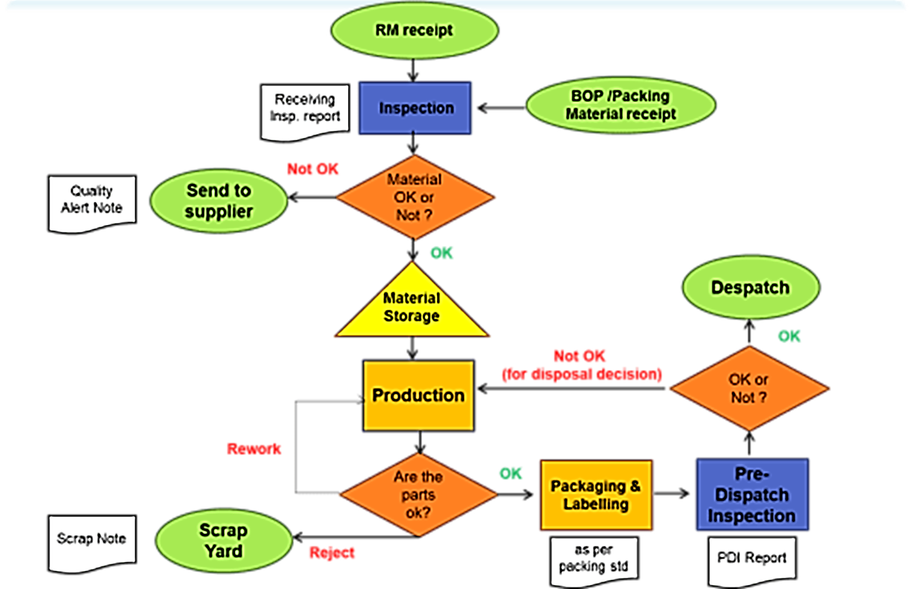
Sample process flow for manufacturing. Investor may modify as per requirement.

Proposed Employment to be generated (Direct & Indirect) in various phases
This section shall provide details of projected employment to be generated (both direct and indirect employment) as per the table below:
Employment | Operation Phase
 | Year 1 | Year 2 | . | . | . | . | . | Year 10
Capacity Utilization | % | % | % | % | % | % | % | %
Designation 1
Designation 2
Designation 3
The above table may be modified as per requirement of the investor.

Project Implementation Timeline
This section shall include the timeline with detailed bifurcation of tasks along with timelines pertaining to commencement of construction and subsequently commencement of operation of the establishment as per the following table:
Slno | Particulars | Timeline
1 | Financial Closure
2 | Project Commencement Date
3 | Project Completion Date
4 | Date of Commercial Operations
The above table may be modified as per requirement of the investor.

Energy Conservation
This section shall provide details of various energy conservation and management plans proposed by the company in the project.

Effluent Treatment
This section shall include the following details:
- Requirement of ETP
- Capacity of the proposed ETP
- Cost of the proposed ETP
- Status of NOC / requisite permissions from Pollution Control Board

Financial analysis to justify the feasibility of the proposed project.

Project Investment
This section shall provide projected details of investments proposed in the project as per the table below:
Sl No | Particular | Investment Amount (INR) | Percentage (%)
1. | Acquisition of Land
2. | Civil Works
3. | Plant & Machinery
4. | Misc. Costs
5. | Pre-Operative Expenses
6. | Contingency & Escalation
7. | Working Capital
The above table may be modified as per requirement of the investor.

Means of Finance
This section shall provide details of proposed project financing in the project as per the table below:
Sl No | Particular | Value | Percentage
1 | Promoters’ contribution (in Cr Rs.) | INR in Cr | %
2. | Term loan (in Cr Rs.) | INR in Cr | %
3 | Unsecured loan (in Cr Rs.) | INR in Cr | %
4 | Others (QIP/NCD/Internal Accrual) | INR in Cr | %
Total |  | INR in Cr | 100%
The above table may be modified as per requirement of the investor.

Assumptions for Financial Model
- Date of Commercial Operations
- Interest rate
- Goods and Services Tax
- Income Tax
- Operational Period (200/300/330 … Days/year)
- Length of Financial Projections (8/10/15/20/30 Years)
- Capacity Utilization Schedule
- Escalation Rates
- Depreciation Rates

Manpower Costs
The manpower costs along with Salary per person per year and escalation rater assumed shall be presented here.
Revenue Head | Yearly Salary | Escalation | Year 1 | Year 2 | Year 3 | Year 4 | . | . | Year 10
Capacity Utilization |  |  | 15% | 30% | 50% | 60% | 75% | 75% | 75%
Designation 1
Designation 1
Designation 1
Designation 1
Administrative Costs
Repair and Maintenance
Power & Fuel
Water
Lease Rent
Distribution Expenses
Total
The above table may be modified as per requirements.

Input/Operational Costs
This section shall provide the input costs per unit, quantity required and total cost thereof at full operational capacity:
Raw Material | Annual Requirement | Per Unit Cost (INR) | Total Cost (INR)
Component 1
Component 2
Component 3
Staff Salaries
Administrative Costs
Repair and Maintenance
Power & Fuel
Water
Lease Rent
Selling and Distribution Expenses
The above table may present figures for maximum projected capacity utilization.
The above table may be modified as per requirement of the investor.
This section shall provide the input costs and the capacity utilization from the Date of Commercial Operations:
Revenue Head | Year 1 | Year 2 | Year 3 | Year 4 | . | . | Year 10
Capacity Utilization | 15% | 30% | 50% | 60% | 75% | 75% | 75%
Component 1
Component 2
Component 3
Staff Salaries
Administrative Costs
Repair and Maintenance
Power & Fuel
Water
Lease Rent
Selling and Distribution Expenses
Total
The above table may be modified as per requirements.

Revenue from Operations
This section shall provide the revenue, capacity utilization and total thereof:
Revenue Head | Year 1 | Year 2 | Year 3 | Year 4 | . | . | Year 10
Capacity Utilization | 15% | 30% | 50% | 60% | 75% | 75% | 75%
Product 1
Product 1
Product 1
Total
The above table may be modified as per requirements.
Revenue stream shall be separated among export and imports in this section following the table above.

Depreciation
This section shall provide the deprecation rates assumed for each component such as Building, Plant and Machinery etc., the depreciation method adopted and the year wise values:
Revenue Head | Rate | Method | Year 1 | Year 2 | Year 3 | Year 4 | . | . | Year 10
Building | % | WDV
Plant and Machinery | % | WDV
Misc. Equipment | % | WDV
Total | - | -
The above table may be modified as per requirements.

Projected Profit and Loss Account
This section shall present the Profit & Loss account for the entire project duration. It shall also present the Tax calculations in detail.
Particulars | Year 1 | Year 2 | Year 3 | Year 4 | . | . | Year 10
Revenue
Component 1
Component 2
Total Revenue
Expenses
Component 1
Component 2
Energy Cost
Labor Cost
Repairs & Maintenance
General & Administrative Expenses
Selling Expenses
Total Expenses
EBITDA
Depreciation
EBIT
Interest
PBT
Tax
PAT
EBITDA Rate
PAT Rate
The above table may be modified as per requirements.

Term Loan Repayment Schedule
This section shall present the debt equity ratio, loan draw down, loan repayment schedule, and interest payments for the entire course of the loan tenure.
% of Investment as Loan
Amount
COD
Repayment Start
Interest Rate (Actual)
Year | Month | Opening Balance | Closing Balance | Debt Drawdown | Addition | Repayment
Mar-25 | Mar-25
Mar-26 | Apr-25
Mar-26 | May-25
Mar-26 | Jun-25
Mar-26 | Jul-25
Mar-26 | Aug-25
Mar-26 | Sep-25
. | . | . | . | . | . | .
. | . | . | . | . | . | .
Mar-32 | Dec-25
The above table may be modified as per requirements.

Debt Service Coverage Ratio
This section shall present the DSCR worked out for servicing the term loan(s).
Particulars | Year 1 | Year 2 | Year 3 | Year 4 | . | . | Year 10
PAT (Profit after Tax) | -
Add: Depreciation | -
Add: Interest on Term Loan | -
Funds Available for Debt Servicing | -
Interest on Term Loan | -
Principal Payment | -
Debt Servicing Obligation | -
Gross DSCR | -
Average DSCR | -
Maximum DSCR | -
Minimum DSCR | -
The above table may be modified as per requirements.

Breakeven Analysis
This section shall present the breakeven analysis for the project.
Particular | Year 1 | Year 2 | Year 3 | Year 4 | . | . | Year 10
Total Revenue
Total Variable Cost
Contribution
Total Fixed Cost
Profit
Cash Fixed Cost
BREAKEVEN %
Sales Required
The above table may be modified as per requirements.

Payback Period
This section shall present the payback period for the project.
Particulars | Year 1 | Year 2 | Year 3 | Year 4 | . | . | Year 10
Project Cost
PAT (Profit after Tax)
Add: Depreciation & Non Cash Expenses
Total Inflow/Outflow
Cash Accrual
Payback Period
The above table may be modified as per requirements.

Fixed Assets Coverage Ratio
This section shall present the Fixed Asset Coverage Ratio for the entire period for the project.
Particulars | Year 1 | Year 2 | Year 3 | Year 4 | . | . | Year 10
Fixed Assets
Long Term Debt
FACR
The above table may be modified as per requirements.

Projected Balance Sheet
This section shall present the Balance Sheet for the project.

Internal Rate of Return (IRR) and Net Present Value (NPV)
This section shall present the equity IRR and the project IRR along with the NPV.
Particulars | Year 1 | Year 2 | Year 3 | Year 4 | . | . | Year 10
Cash Outflows
Cash Inflows
Net Cash flow
Internal Rate of Return
The above table may be modified as per requirements.

Annexures

ST Certificate of Promoters from the State
This annexure shall present the ST certificate of each local promoter/director of the applicant(s).
*Note: The below illustrated ST Certificate is indicative and shall only be used for reference purposes.

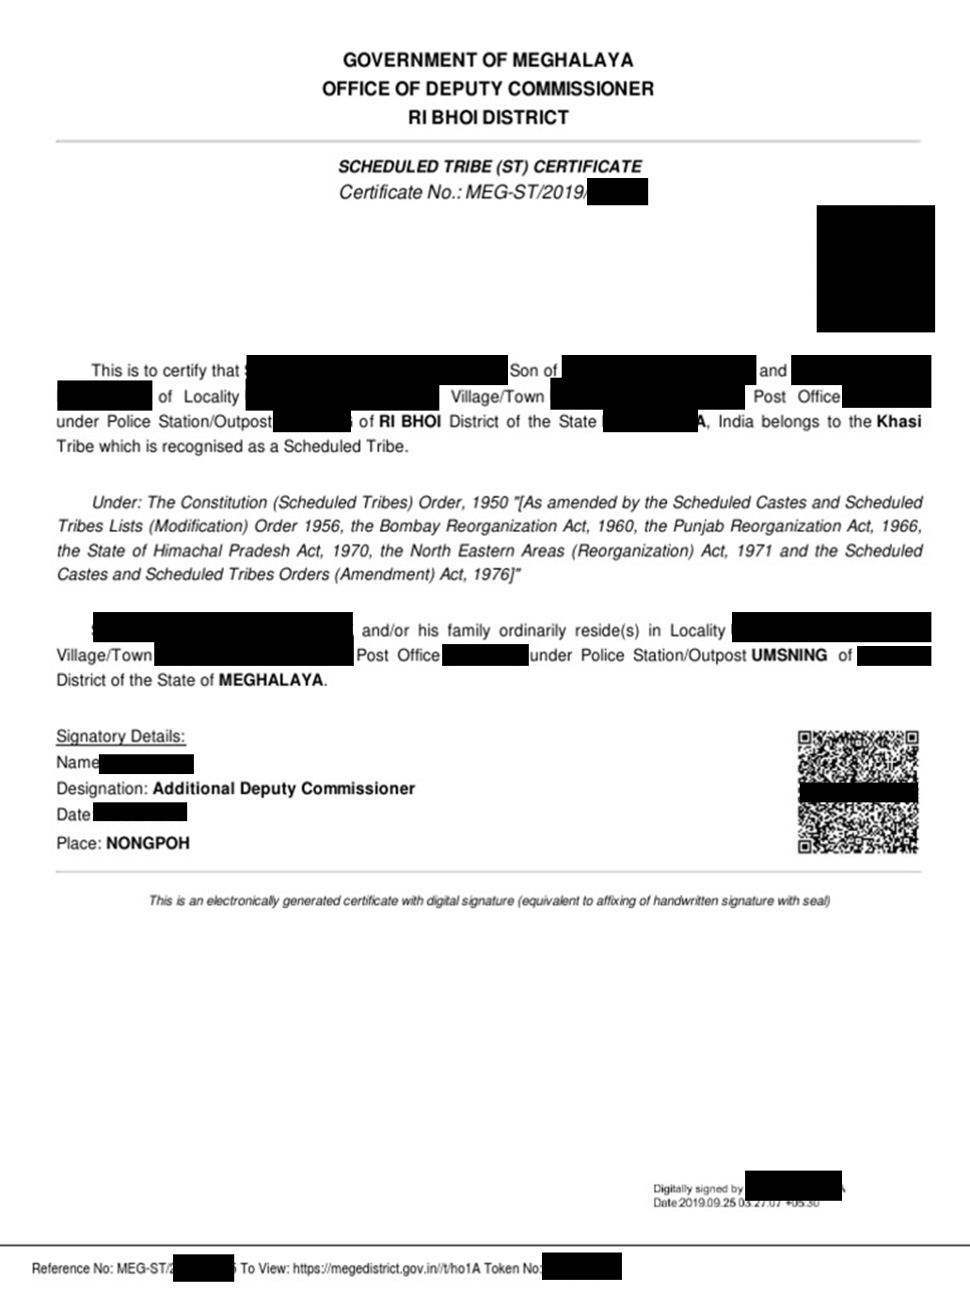

Net worth Certificate
This annexure shall contain the Net worth Certificate of each promoter duly certified by a Chartered Accountant.
*Note: The below illustrated Net worth certificate is indicative and shall only be used for reference purposes.
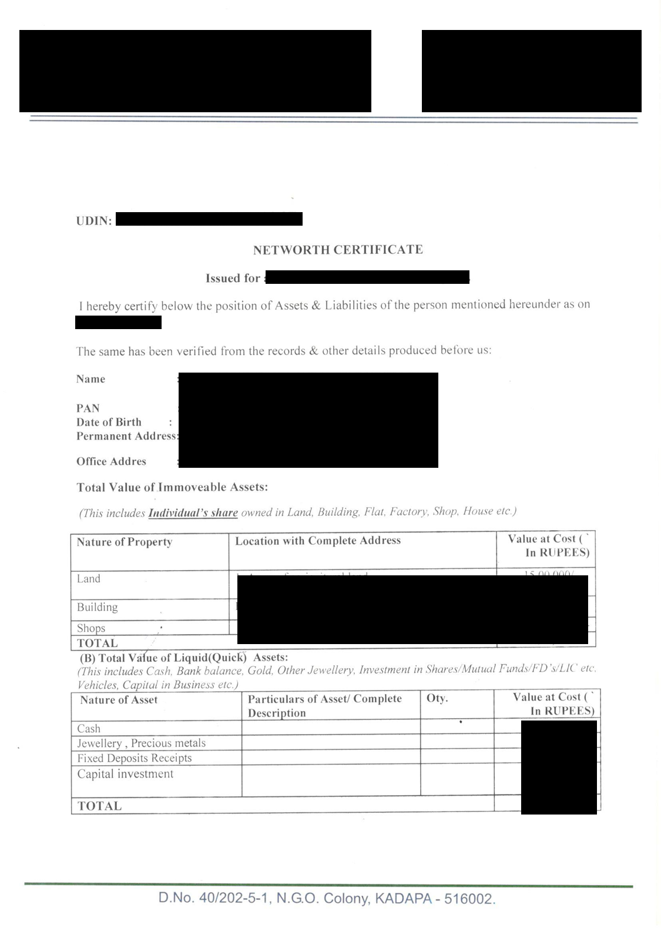
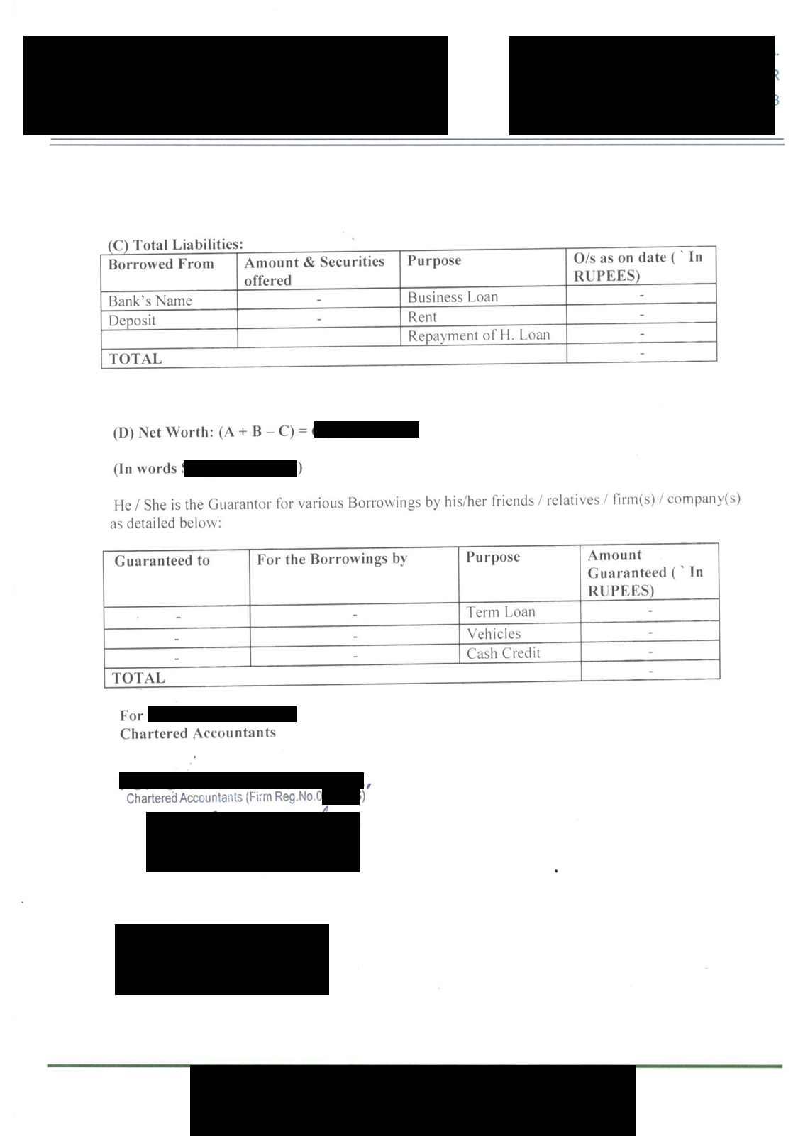

Audited Balance Sheet
This annexure shall present the audited Balance sheet for the past 3 years.
*Note: The below illustrated ST Certificate is indicative and shall only be used for reference purposes. This annexure is not mandatory in case of a new company.
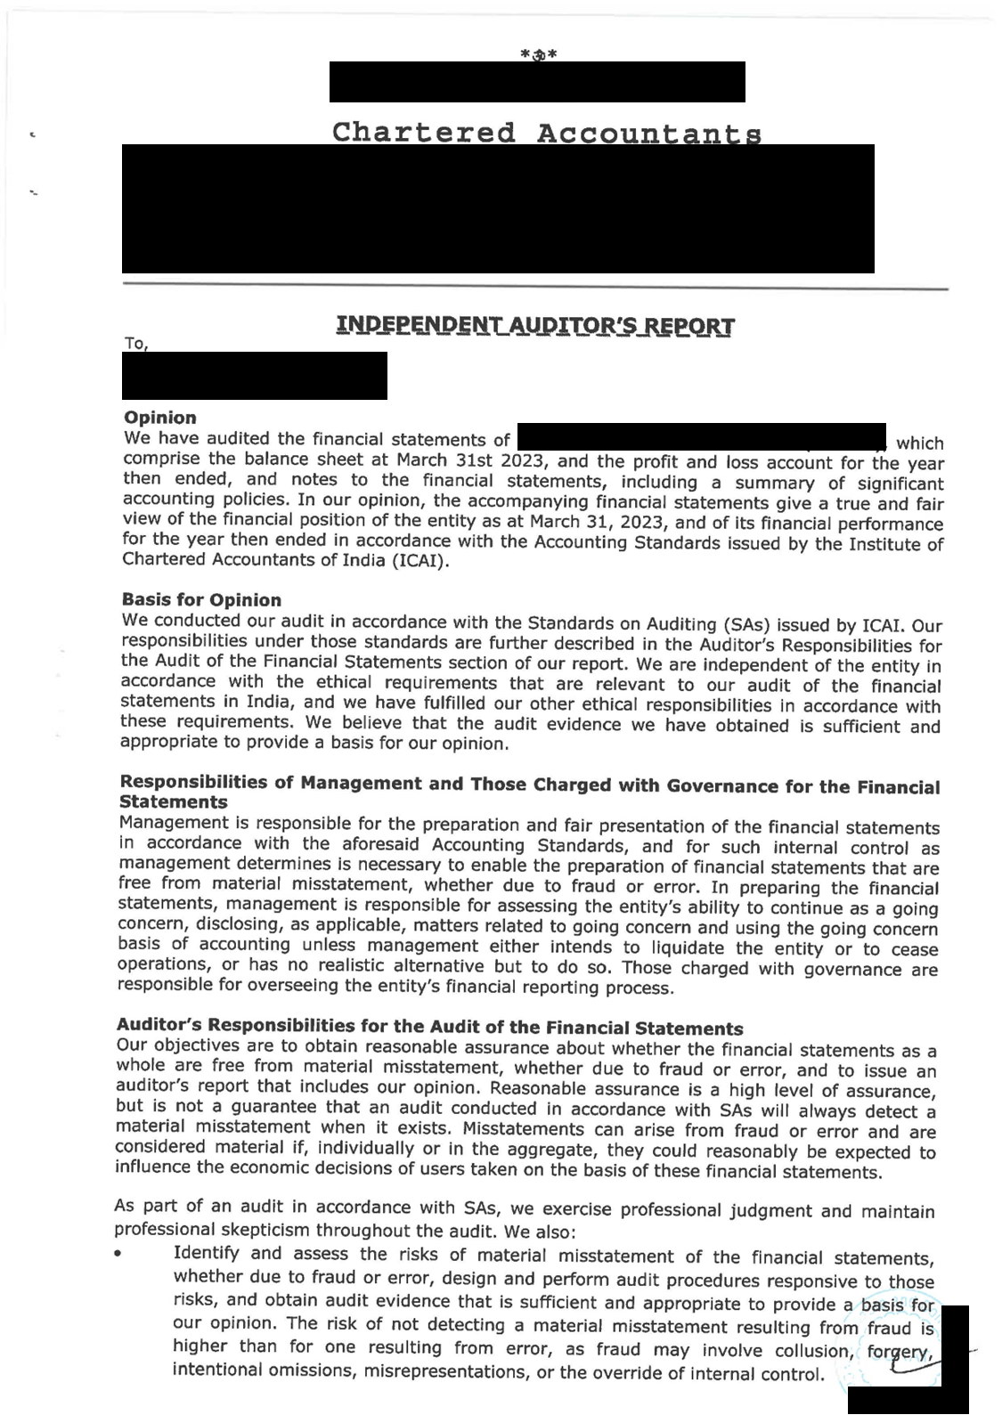
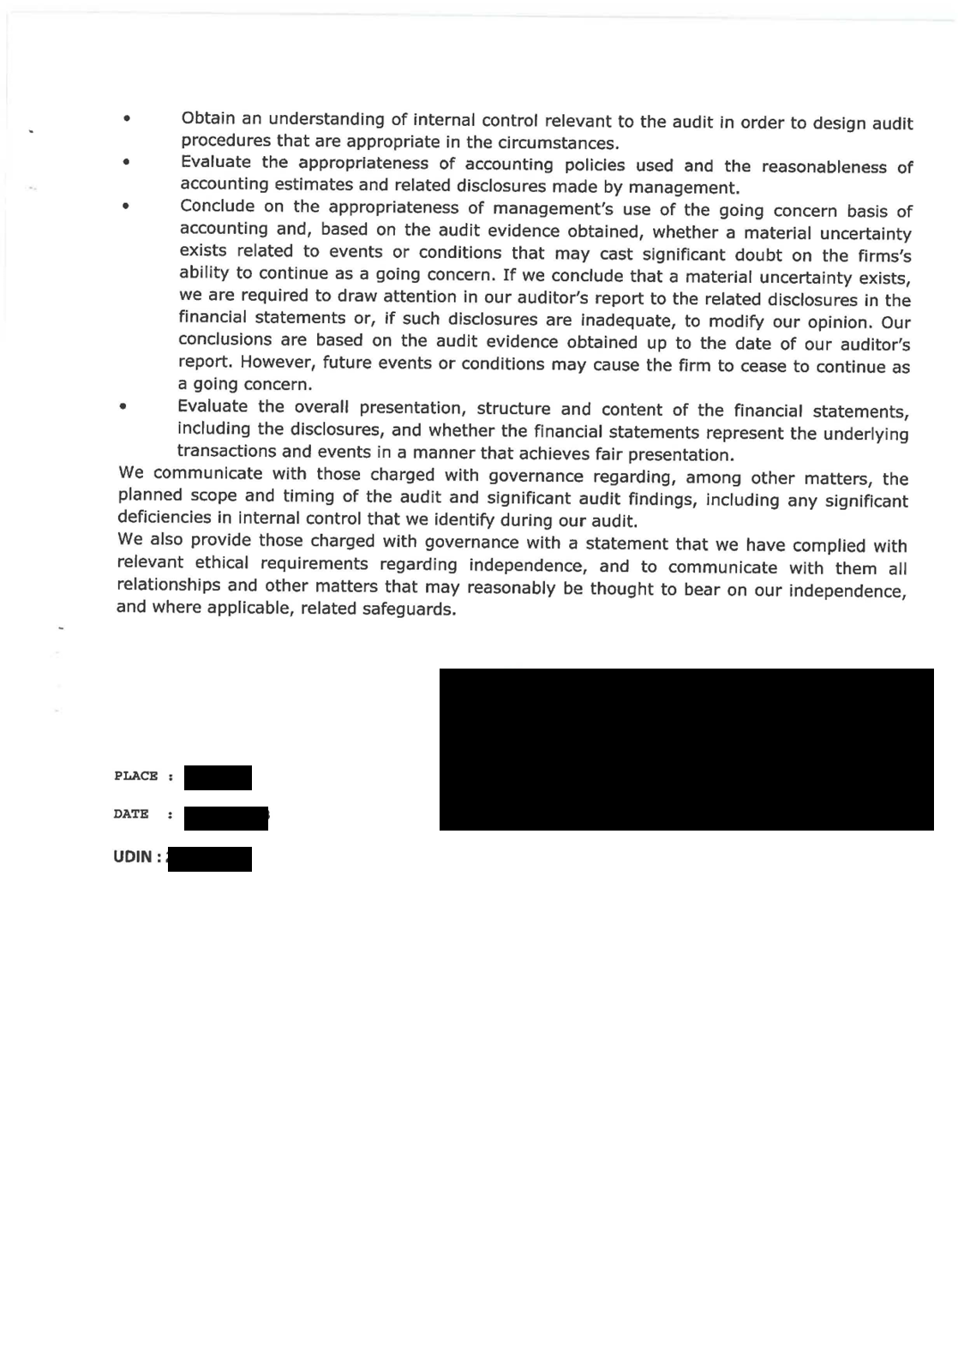
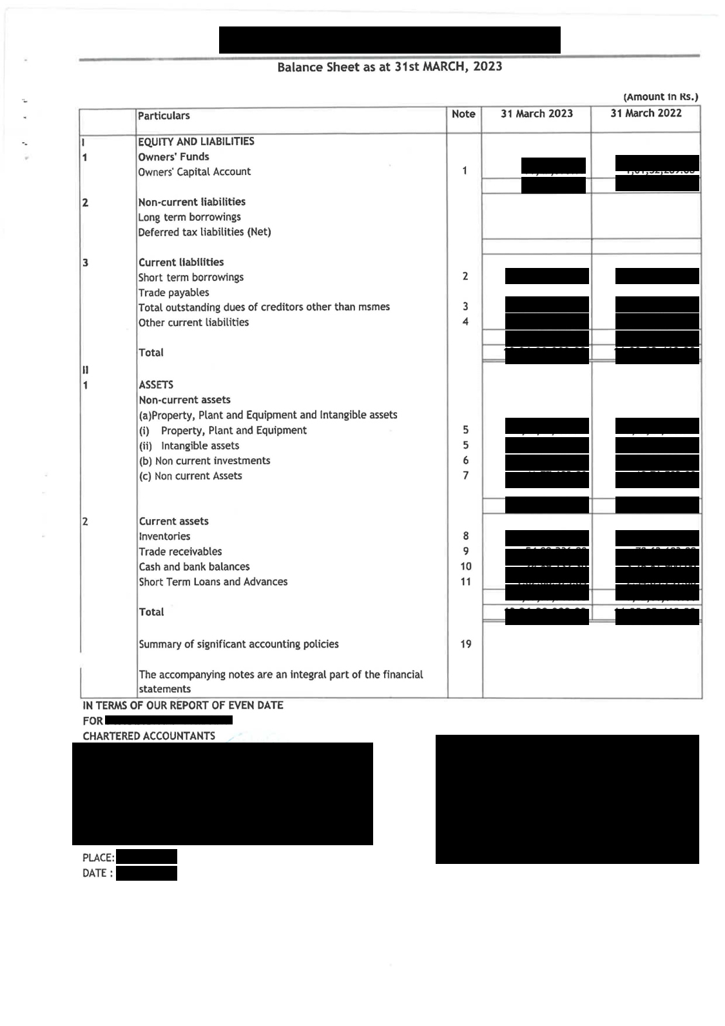
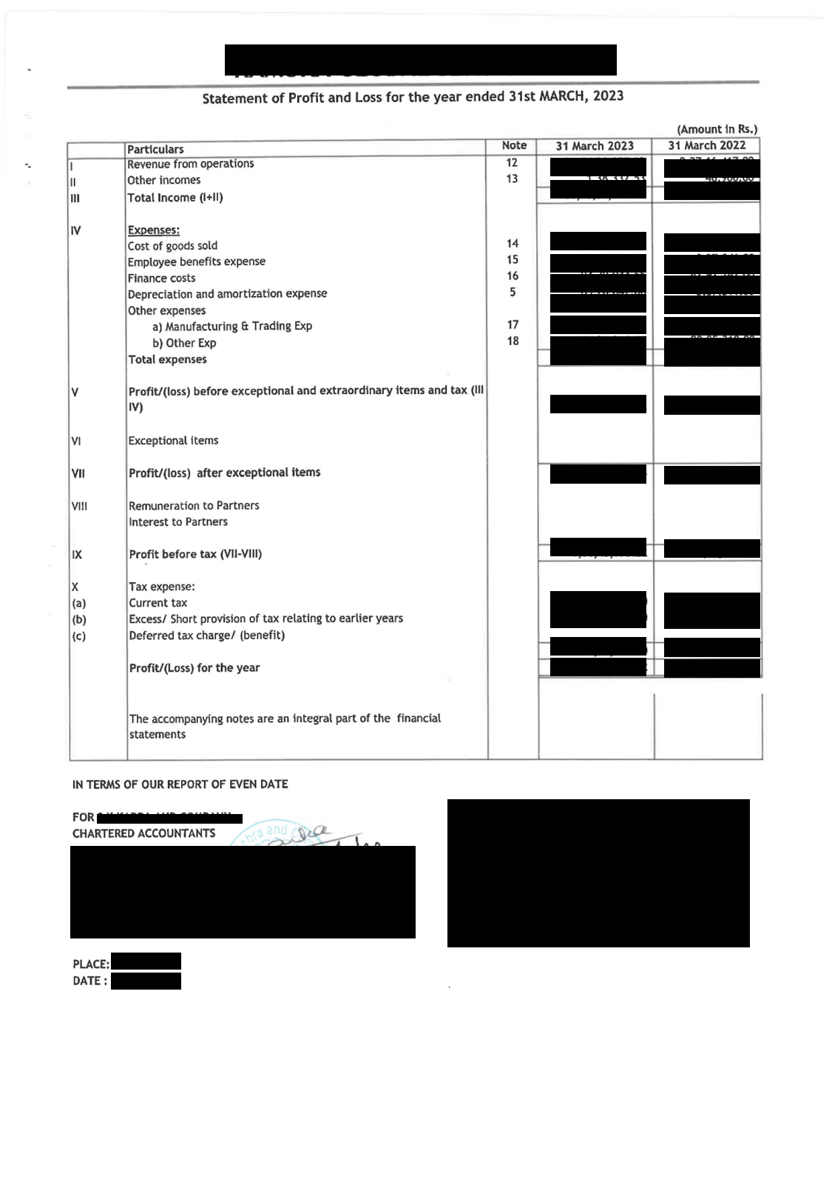
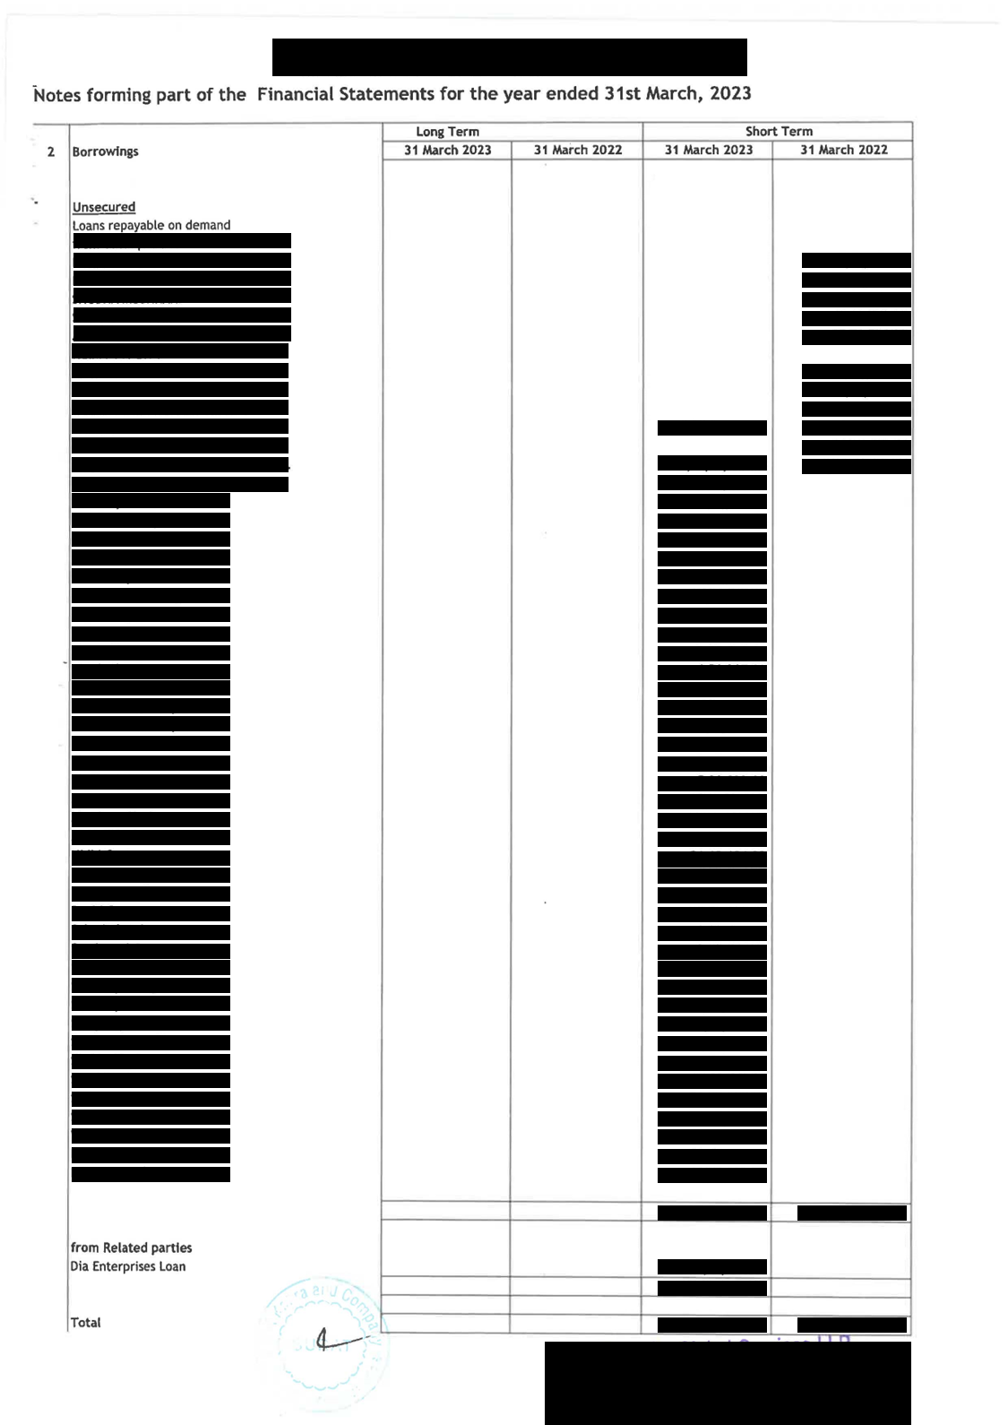
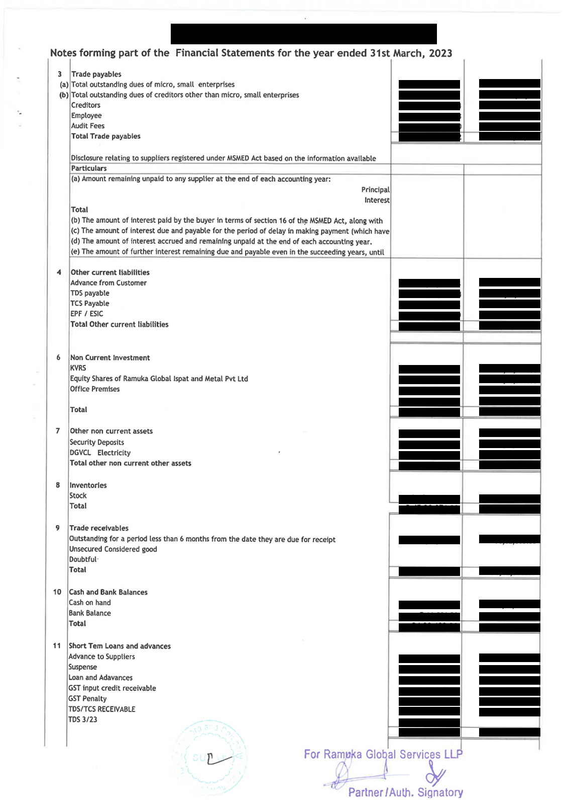

The audited balance sheet shall also present the details of the fixed capital, the current account and the property, Plant & Equipment and Intangible assets (Owned Assets).
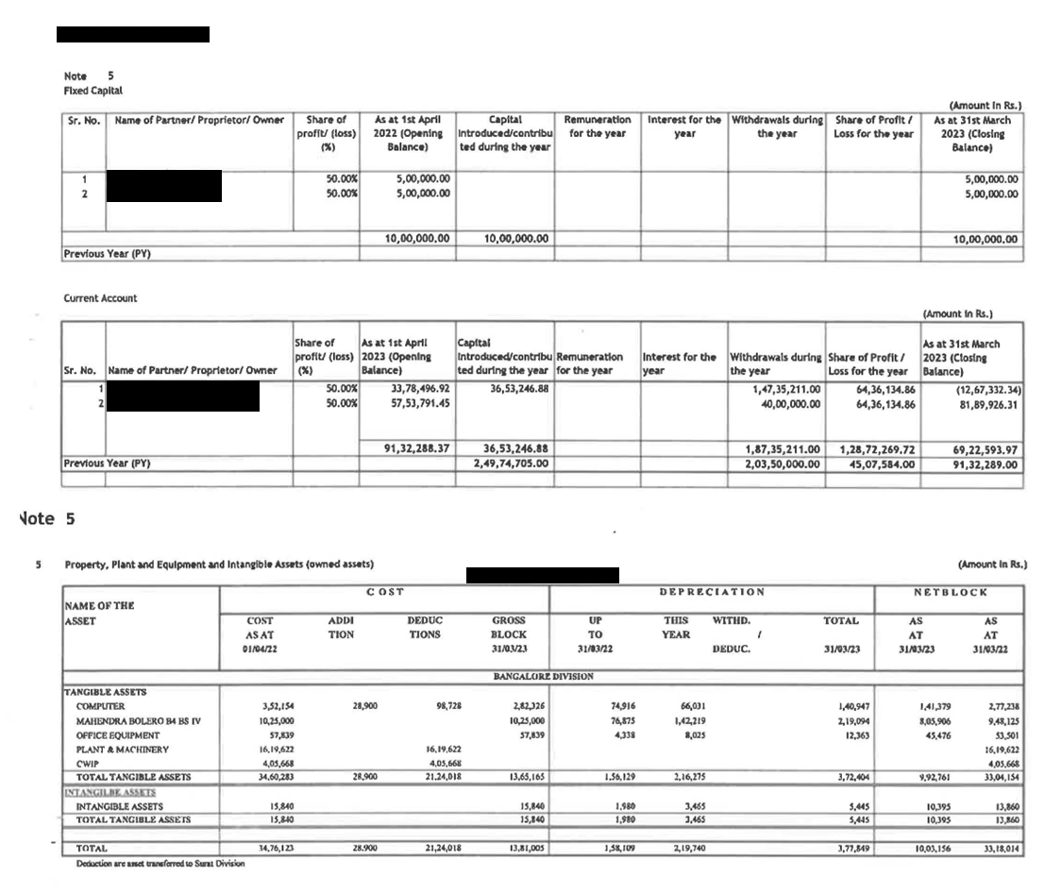
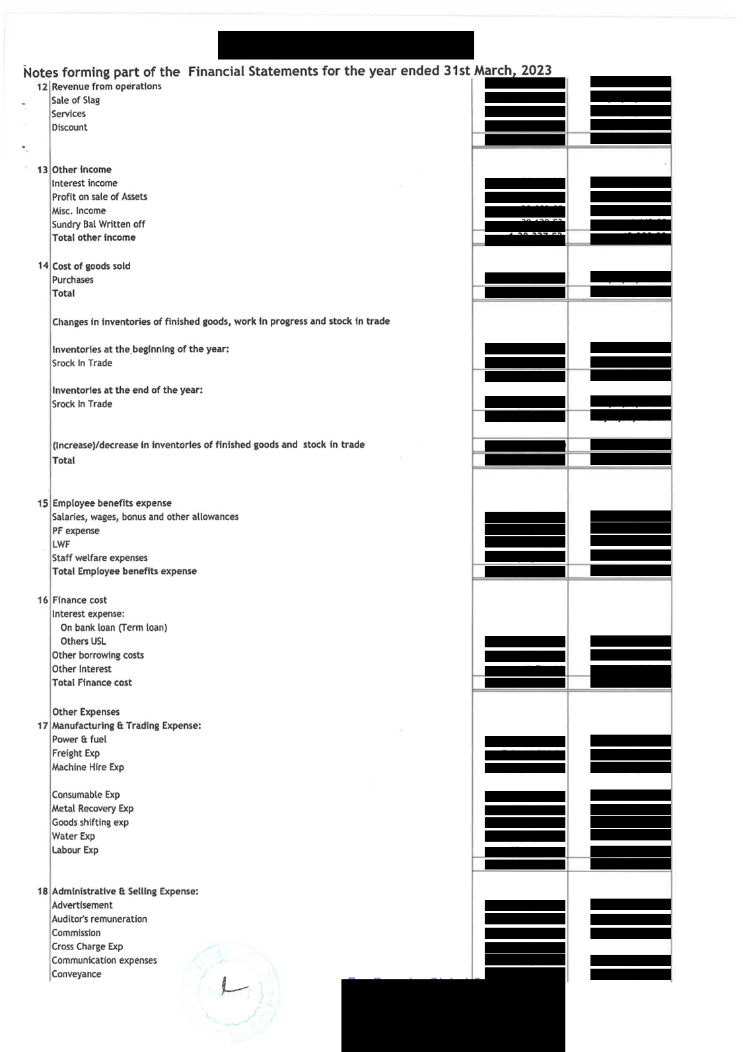
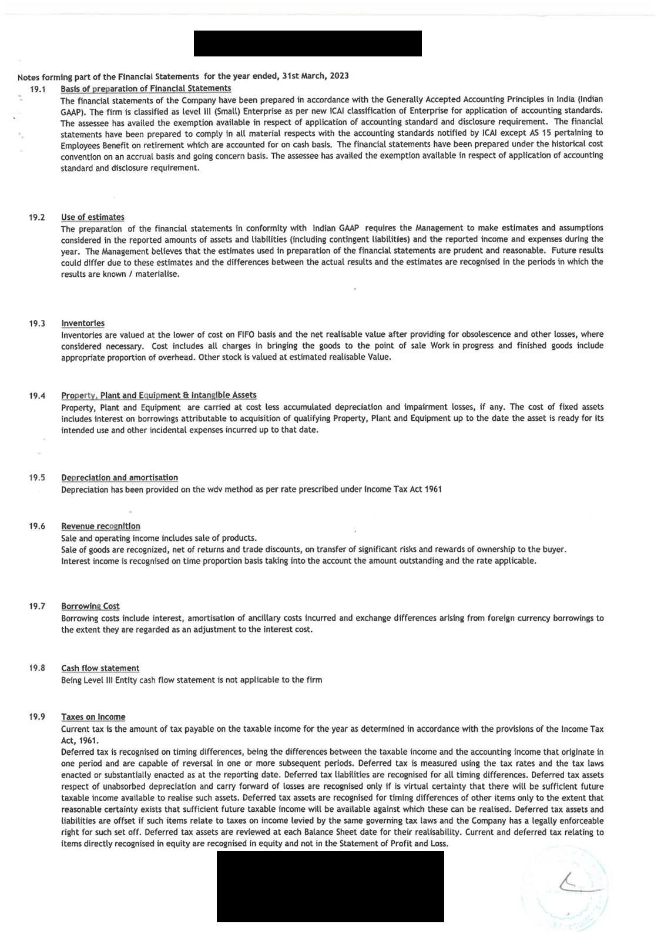


Memorandum of Association
This annexure shall present the Memorandum of Association.
Note: This annexure is not mandatory in case of Proprietorship Concerns.

Land Documents
This annexure shall present the land documents if the land is leased/owned by the promoters.
Note: If Land is to be allotted, this annexure is not mandatory.

Master Plan/ Site Plan
*Note: The below illustrated site plan is indicative and shall only be used for reference purposes.
Applicant to provide a schematic site plan in case Land Allotment is required
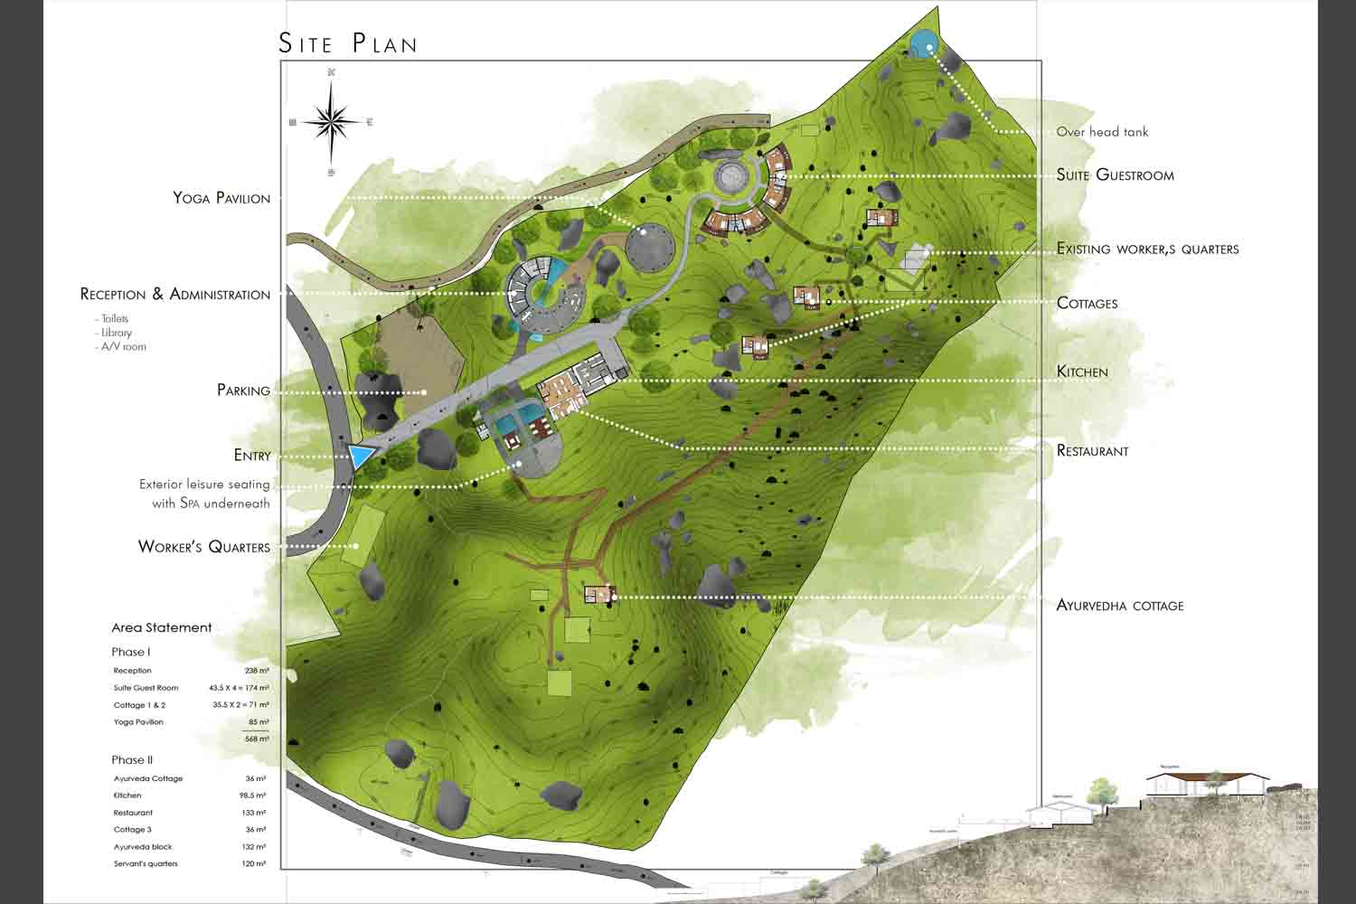

Layout Plan
*Note: The below illustrated layout plan is indicative and shall only be used for reference purposes.
*Note: Applicant to provide a schematic layout plan in case Land Allotment is required
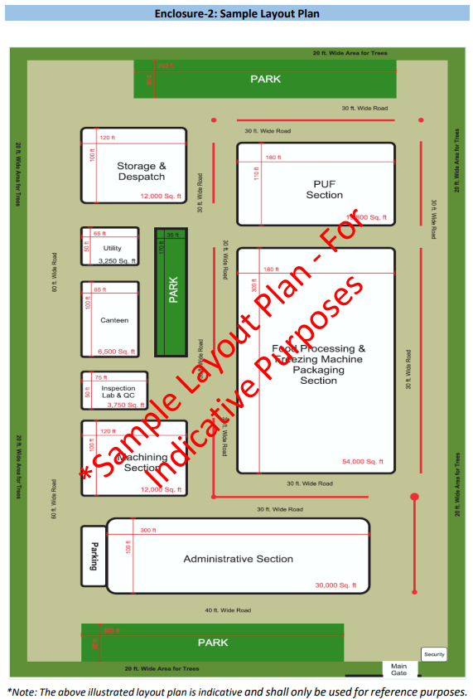

Area Statement
*Note: The below illustrated area break up statement is indicative and shall only be used for reference purposes.
Note: Applicant to provide a tentative area statement in case Land Allotment is required
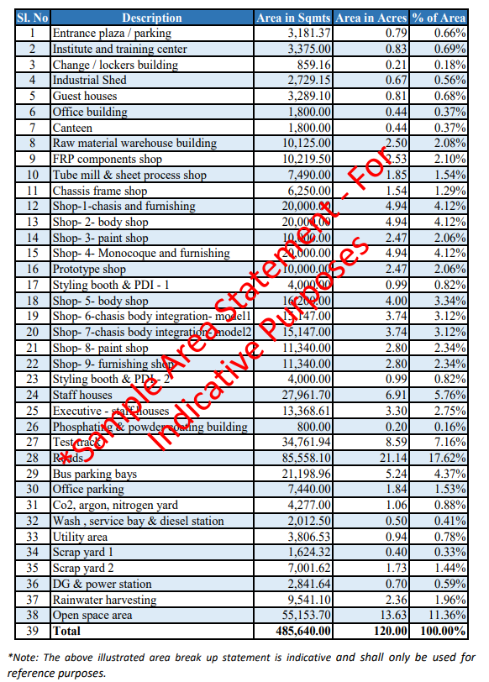

Civil Works Estimate

No | Building Particulars | No of Floors | Built up Area | Cost | Unit | Amount (INR)
Civil Works
1 | Basement | 1 |  |  | /Sqft
2 | Lobby | 1 |  |  | /Sqft
3 | Banquet Hall | 2 |  |  | /Sqft
4 | Restaurant and Kitchen | 1 |  |  | /Sqft
5 | Lodging | 4 |  |  | /Sqft
Interiors
1 | Restaurant and Kitchen |  |  |  | /Sqft
2 | Lobby | 1 |  |  | /Sqft
3 | Lodge | 4 |  |  | /Sqft
4 | Bar | 1 |  |  | /Sqft
5 | Banquet Hall | 2 |  |  | /Sqft
Services
1 | Air Conditioning System | 5 |  |  | -
2 | DG Set | - |  |  | -
3 | Elevator | - |  |  | -
4 | Transformer and Power Line | 5 |  |  | -
5 | Plumbing | 5 |  |  | -
6 | Electrical Works | 5 |  |  | -
Misc. Works
1 | Site Development | - |  |  | Acre
2 | Landscaping | - |  |  | Acre
3 | Access Road | - |  |  | Sqm
4 | Entry Gate | - |  |  | -
5 | Street Lighting | - |  |  | Nos

SIGN OF CHARTERED CIVIL ENGINEER
NAME:
QUALIFICATION:
DATE:

Note: If project is in conceptual/inception stage and Land allotment is required, Chartered Engineer Certification is not mandatory

List of Plant and Machinery

Purpose | Description | Quantity | Unit Price | Total Price (USD)
Mammography | Analog Mammography
CR System | CR System and printer
CT scan (16 Slice) | CT (64 slice)
. | Syringe infusion pump
. | Defibrillator, Monitor, without Pacemaker
. | MRI machine (1.5T)
. | . | . | . | .
. | . | . | . | .
. | . | . | . | .
. | . | . | . | .
. | . | . | . | .
. | . | . | . | .
Total |  |  |  | .

Consent Letter for Equity Contribution
Note: This annexure shall present the consent letter on a stamp paper, duly signed by the relevant partners in case equity contribution of any one of the partners falls short due to net worth inadequacy. If not applicable, this annexure is not mandatory
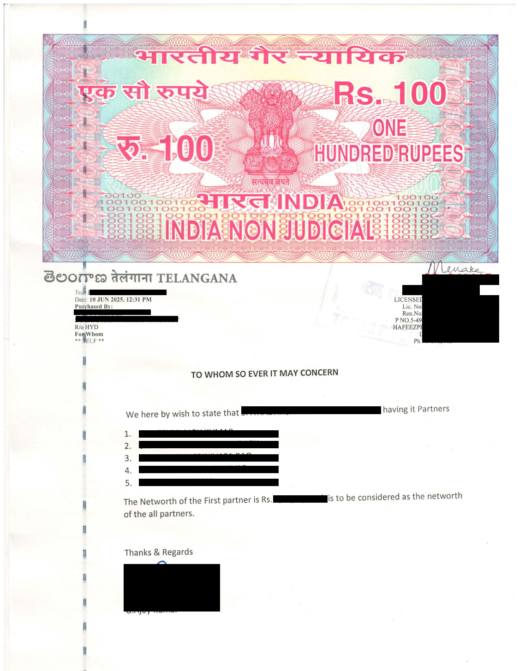

Single Window Approval Copy
Note: This annexure shall present the Letter with Single Window Approval. If not yet received, this annexure is not mandatory
